### SUSTECH ME 425 Sensing Technology

**Acceleration and Force of Mass-Spring System**

In this lab, we will introduce you a typical aspect of system identification – the impulse response - and learn how to determine a 2nd order system transfer function using the measured impulse response, and then using a random noise (stochastic) signal to determine system properties. The first part of this lab will teach you more ways to ensure that you obtain useful data when you make measurements, covering topics of sensor accuracy, resolution, dynamic range, clipping, and sample rate for impulse experiments. You should have read the background material before coming to lab, which will introduce you to much of the material you will do in lab.

**Learning Objectives:**

**Experimentation and data collection**: Vary experimental parameters as needed to produce useful data

* Recognize useful vs. useless measured signals and if necessary resolve issues such as resolution limitations, inadequate sample rate, and clipping by varying experimental parameters.

**Signal analysis and system identification:** Determine the input-output relationship of a system using impulse and step response, frequency response and transfer functions (Bode plots)

* Use inputs such as **impulse**, step, and **stochastic** signals to excite a system and measure the input and output signals in order to determine the non-parametric transfer function and display it as a Bode plot
* Use the system impulse response function and system transfer function to predict the system output for a given input

**Part I: Week of March 18-23**

### 1. Introduction to the Experimental Setup

The experimental mass-spring system you will build in lab today is similar to the one shown in Fig 1. The mass-spring system is suspended from a load cell at the top of the apparatus. The acceleration of the attached mass will be measured by a 3-axis accelerometer unit, adhered to the bottom of the mass, and the load cell force, read by a strain sensitive resistor placed on top the spring. Acceleration and Load Cell Force need not be measured at the same time.

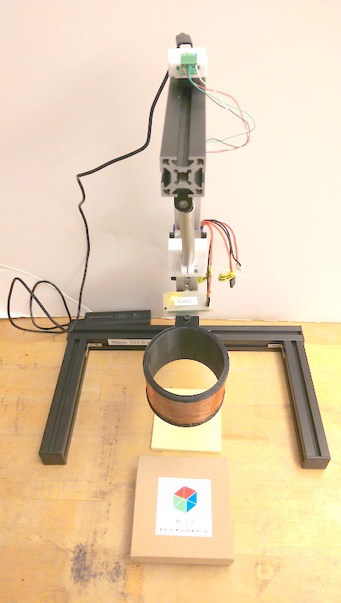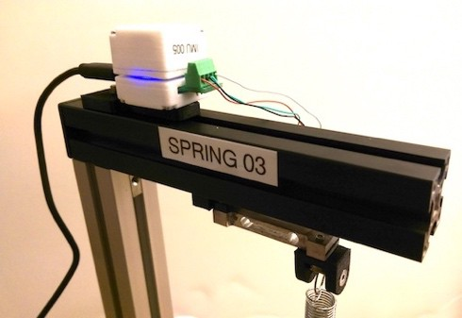

3-axis

accelerometer

Load Cell

Electromagnetic coil (to be replaced by ring magnets)

Sticky notes to use as shims

**Figure 1:** Components of the force and accelerometer system you will use in lab today, showing the load cell, and the 3 axis acclerometer.

Record the part number of the sensors and Arduino UNO circuit. At the same time, record the Mass listed on the bottom left corner of the setup with units.

### Collecting Useful Data

In this section, let's experiment on how to distinguish between useful and useless measured signals and, when needed, resolve issues such as inadequate sample rate, resolution limitations, and clipping by varying experimental parameters. In many cases, you will want to measure an event of short duration, such as a boxer hitting a force plate, or an accelerometer experiencing a sudden change in direction. This type of experiment is referred to as an “impulse experiment”, since the event is of short duration and, usually, high amplitude. We must select the sample rate for impulse experiments very carefully to ensure that the data we collect are meaningful and can be analyzed further. We also must be concerned about the presence of noise in our signal, and whether the sensor range and resolution are adequate for our task.

#### Accuracy and Resolution of 3-Axis Accelerometer

You should already be aware that there are two different measures of the "goodness" of your data: **precision** and **accuracy**. **Precision** refers to the repeatability of the results. If you perform the same experiment under the same conditions a large number of times, the precision can be determined from the spread in the results. In other words, random errors in the data decrease the precision of the measurement. The precision uncertainty is related to the standard deviation of the data, and can be computed from a statistical analysis of your measurements. The precision also depends on the sensor resolution, defined as the minimum detectable change in signal.

**Accuracy** is defined as the difference between the measurement and the "true" value. In many cases, this is difficult to determine, because the true value is not known (why would you measure something you already know?) Systematic errors result in decreased accuracy. Systematic errors are much more difficult to identify than random errors, since they introduce a constant shift in the results, rather than a scatter in the results. Without a priori knowledge of the “true” result, a shift in the measured value is essentially impossible to detect. However, in this case, we know the acceleration due to gravity quite well. In fact, Prof. Ian Hunter has looked it

up and it is listed in the front of the room for this spot on the Earth to five significant figures! (9.8038 m/s2).

#### Accuracy

1. Connect your Arduino UNO with the 3-axis accelerometer, and communicate with Matlab. Display all 3 accelerometer columns (X, Y, Z) on the vertical axis by **single** left- clicking on the vertical axis label of the graph to bring up the Y-axis options, and selecting **All of the above.** The X- and Y- axes should be near zero and the Z should be near 10 m/s2.
2. Use the Statistics button to take the mean of all 3 data traces and record the mean and standard deviation for each channel in your lab notebook, making sure to clearly list which axis corresponds to which mean value.
3. Record the accuracy for each channel in your lab notebook, i.e. the difference between the mean and the expected value (0 for x,y and *about* 9.8038 for z). How does your measured accuracy compare to the specification of the accelerometer?
4. Save this Matlab file, recording the filename and conditions in your lab notebook, in case you want to refer to it later.
5. Since the z-axis values are sitting on a large offset (1 g), you want to only display either **X (m/s^2)** or **Y (m/s^2)**, so that you can expand the y-range and look in detail at the signal.
6. Your sensor results should look similar to the following graph, where you can clearly see that there is a minimum **vertical** spacing, circled in green. The points are separated by fixed steps which are all integral multiples of this minimum spacing. Zoom inthe figures produced by Matlab, record in your lab notebook the values on either side of any minimum step (make sure to select the **smallest** vertical steps visible in your data, circled in **green** below) and compute the resolution, defined as the **difference** between these values in m/s2. Record all the digits available to you through the Examine dialog box. Do this for a few steps, to verify that the resolution is constant.

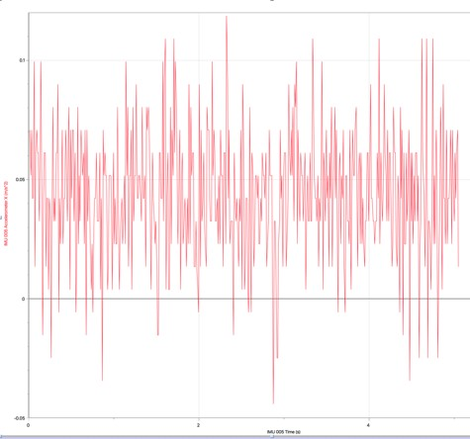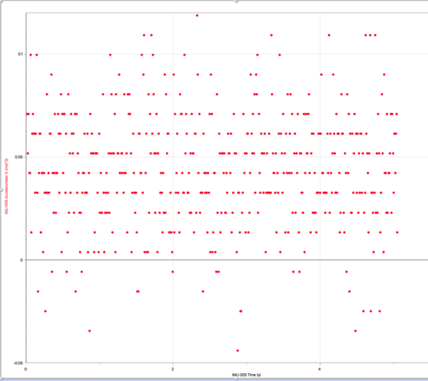

Does your measured resolution agree with the specification? If not, talk to ME 425 lab staff.

The table demonstrates the inverse relationship between Range and Resolution that results from the 12-bit ADC. The range is divided into 212 = 4096 levels, so that a total range of 4g (2g range) corresponds to a resolution of 4g/4096 = 9.8**10-4 g/level = 0.0096 m/s2. You need to keep in mind this tradeoff between range and resolution; as you learned with the oscilloscope, you want your signal to fill as much of the available range as possible.

You have just observed another ME 425 fundamental principle on **PRODUCING USEFUL DATA: Recognize resolution limitations.** You must always be alert to the problem of inadequate resolution, indicated by discrete steps in the data, as you observed above. Inadequate resolution can be fixed a number of ways: (i) changing your sensor to one with better resolution (in this case the range and thus resolution can be changed in software), (ii) increasing the size of your signal (not always possible), or (iii) using averaging techniques to “fill in” the discrete steps caused by insufficient resolution

#### Sample Rate for Impulse Experiments

In the Identifying Music lab, you learned about aliasing and the need to properly select your sample rate when measuring periodic signals to accurately measure the frequency content of the signal. In many cases, you will not be measuring periodic signals but “impulses”, i.e. events, often of a short duration, such as a bat striking a ball or finger hitting a piano key. In this case, you need enough samples during the duration of the peak to allow you to determine quantities of interest, such as peak height and time width (remember the concept of full width at half maximum (FWHM) introduced in a previous lab).

Whenever doing impulse experiments, make sure to look in detail at all peaks in your data to ensure that you have adequate sample rate to determine peak height and width. We want to examine the signal in more detail. We need to be able to see the actual recorded points, which you can see are listed in the table to the left of the screen.

* + 1. There may be a non-physical spike in the beginning of the data set, if so, highlight the very beginning of the data trace (click and drag your cursor across relevant region of the x-axis) and then remove the transient spike at the very beginning of the data**.**
    2. Your graph should now appear similar to that below:

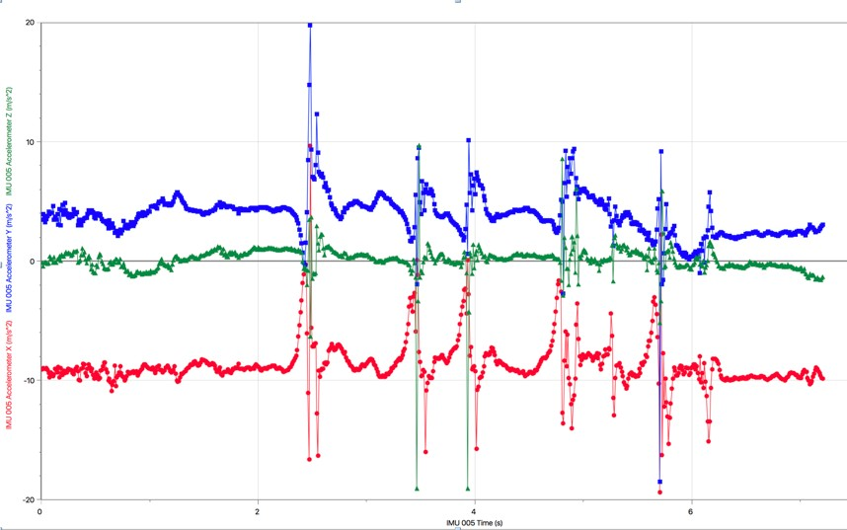

* + 1. How many points would you say are on each peak? Comment in your lab notebook.
    2. Do you think you could use these data to determine either true peak height (i.e. real maximum acceleration, not the value displayed on the screen) or true peak width? If you are unsure, ask Lab professor.

Note: Some peaks may have more than one point on the peak, but you should see that too many have only one point at the “top” of the peak, which means that the actual peak acceleration could have occurred before or after the single data point at the “top” of the peak, and therefore you didn’t really measure the maximum acceleration, or have any way to measure peak width. (*You are seeing an example of why we don’t want you to connect points with lines in your own data – your eye assumes that the data increase linearly from the baseline up to the peak, but with insufficient number of samples, it is impossible to tell the peak shape*).

* + 1. Recording the filename and conditions in your Lab Notebook.

### Impulse Response

You are finally ready to do start the main objectives of this lab! In Lab 2: Identifying Music you learned how to measure the system frequency response and display as a Bode plot. Another way to find information about a system is to measure the impulse or step response, as described in the prelab reading. We will start with the impulse response.

1. Use a tape to attach the accelerometer to bottom of the mass. **Place it with the contacts facing up** to avoid shorting on the conducting mass.
2. Select the **Settings** tab and set up both sensors, and change to **100 Hz sampling rate**, and only the Z axis selected.
3. **Collect Data on Matlab** to make sure both sensors are properly connected.
4. Ensure that the mass is still, perhaps by stabilizing it at the point where it is connected to the spring.
5. **Press the spring and save** the data using Matlab. Change the Y-axis of the graph to display both load cell and Acceleration (Z). to remove the transient spike at the very beginning of the data, and then **Autoscale.** Your graph should appear similar to that below. You can remove the offset easily in Matlab by finding the average of the region before the pulse, and then subtracting it from the data with a Calculated Column in Matlab. Ask lab staff if you need help.

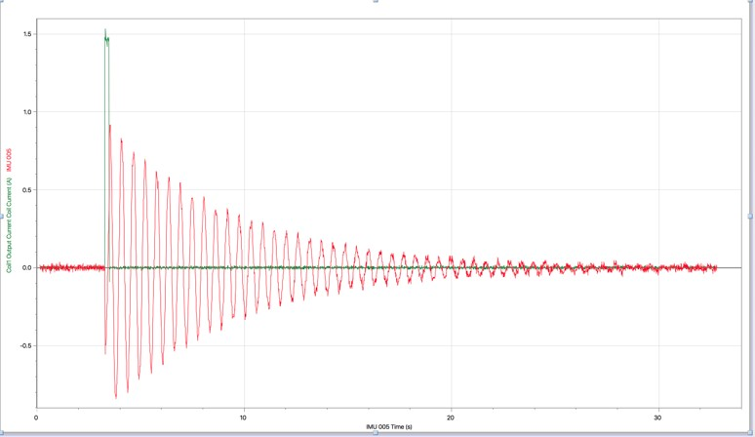

Congratulations! You have just achieved another ME 425 learning objective: **Use an impulse** to excite a system and measure the input and output signals in order to determine the non- parametric **impulse response** (***non-parametric*** *means that you have directly measured the impulse response without making any assumptions as to the order of the system, i.e. without making any assumptions about the 2nd order parameters , *n*,  (or K, M, C).*

### Stochastic System Response

You will now take data using an advanced method for measuring system identification, with a random “stochastic” input function. The input you will use is hard-limited, i.e. the current takes on one of two values: zero, or a single positive value. The time interval between changes in current between these values is determined by a random number generator, thus resulting in a binary stochastic input signal (“binary” because the current takes on one of two possible values).

The advantage of stochastic input over a swept sine input, as you did in the previous lab, is that the experiment can proceed much more quickly. The natural frequency of the system you are using in lab today is of order 1 Hz. In order to study this system with a swept sine input, you would probably want to start at a frequency of 0.1 Hz and scan up to 10 Hz or more. The problem is that at least 10 cycles are needed at each frequency, so such a scan could take 10 minutes or more. In contrast, a stochastic signal contains all the frequencies at once, and therefore accurate data can be taken in a much shorter time. For now, you will simply record the data to be analyzed in the post-lab.

1. Ensure that the mass is still, perhaps by stabilizing it at the point where it is connected to the spring.
2. Press **Start Collecting** and then, after about 1 sec, **Stochastic.** You should see the mass start to oscillate somewhat randomly once the coil is energized.
3. Assuming your data look similar to that shown below, save your sensor data and Matlab file.

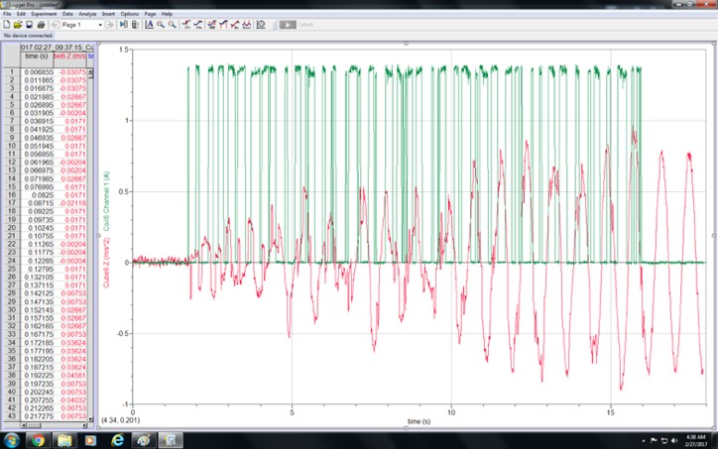

Congratulations, you have finished the experimental portion of week 1 for Mass Spring Lab!

1. Please reconnect the mass to the small magnet on the support to prevent stretching the spring while not in use
2. Please put the tape and paper cutter back on the top shelf and the scissors back in the drawer
3. **EMAIL ALL DATA FILES** to yourself and your partner since you will need them for post-lab analysis
4. The postlab work starting in Sect 5 must be completed independently. It is not necessary to write anything in your lab notebook while doing the postlab, but you are welcome to do so (it may be helpful!)
5. When you are ready to leave lab, remember to get your lab notebook signed before you leave!